Steps to create React app and simple demos

Npx create-react-app my-app

Open myapp in vs code🡺 Terminal 🡺 npm start

It will run in localhost:3000

Index.js 🡺 is the entry point of your application

App.js🡺 is the root component of the application

App.js

import logo from './logo.svg';

import './App.css';

function App() {

  return (

    <div className="App">

      <header className="App-header">

        <img src={logo} className="App-logo" alt="logo" />

        <p>

          Edit <code>src/App.js</code> and save to reload.

        </p>

        <a

          className="App-link"

          href="https://reactjs.org"

          target="_blank"

          rel="noopener noreferrer"

        >

          Learn React

        </a>

      </header>

      <h2>Sample Text</h2>

    </div>

  );

}

export default App;

app.css

h2{

  background-color: aquamarine;

  color: brown;

}

Check it in the browser

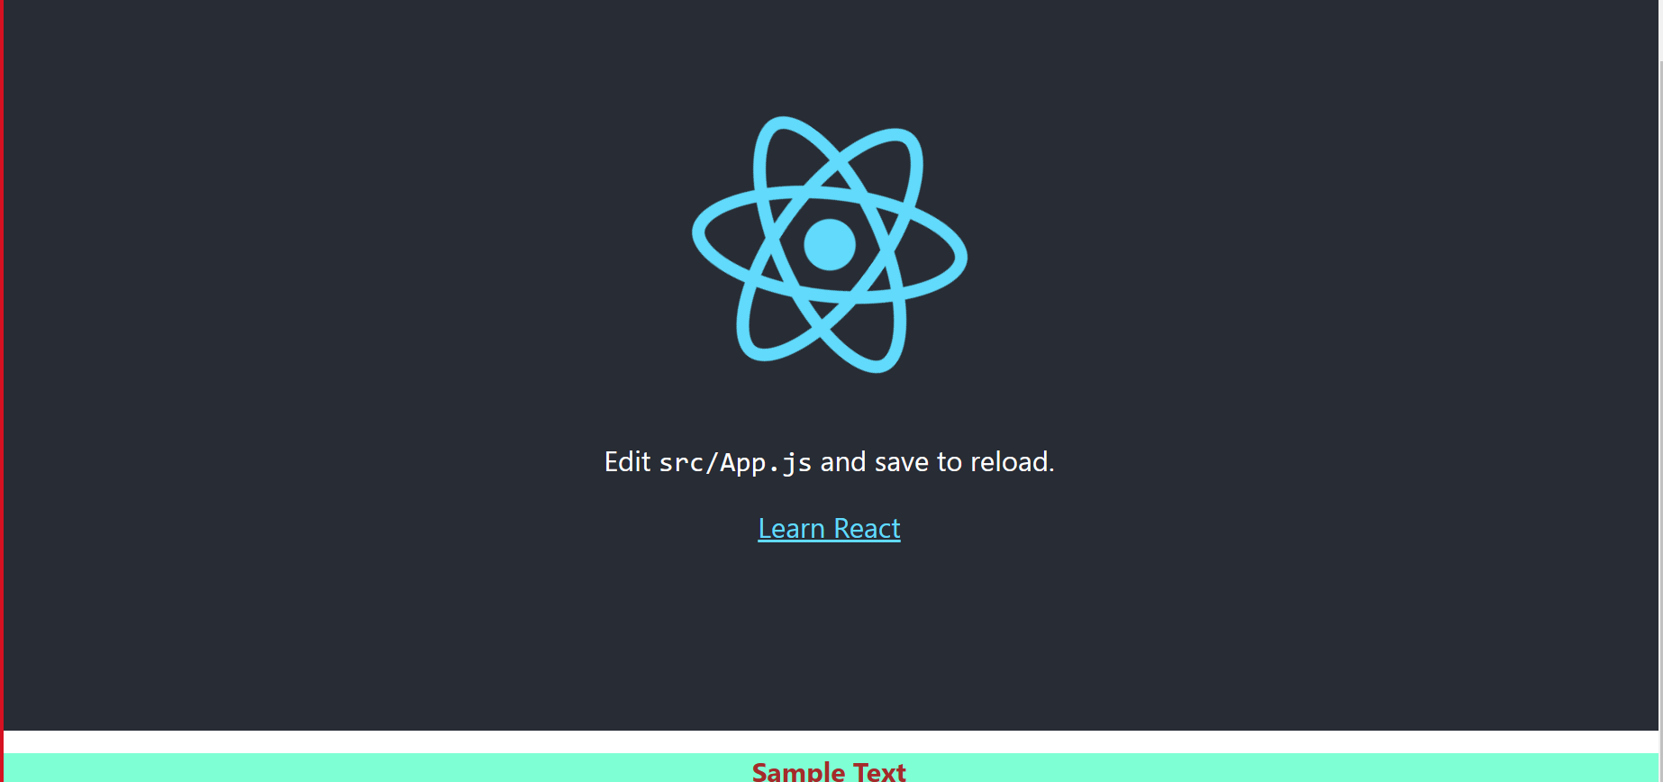

Index.js

Declare js variable the content

import React from 'react';

import ReactDOM from 'react-dom/client';

import './index.css';

import App from './App';

import reportWebVitals from './reportWebVitals';

const element=<h1>Hello Team ,Welcome to React</h1>

const root = ReactDOM.createRoot(document.getElementById('root'));

root.render(

  <div>

    {element}

    </div>

  // <React.StrictMode>

  //   <App />

  // </React.StrictMode>

);

// If you want to start measuring performance in your app, pass a function

// to log results (for example: reportWebVitals(console.log))

// or send to an analytics endpoint. Learn more: https://bit.ly/CRA-vitals

reportWebVitals();

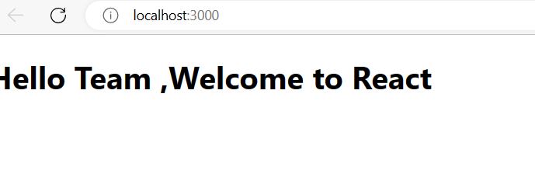

Goto App.js

modify the file with below code is showing how to declare the variable and display it in browser

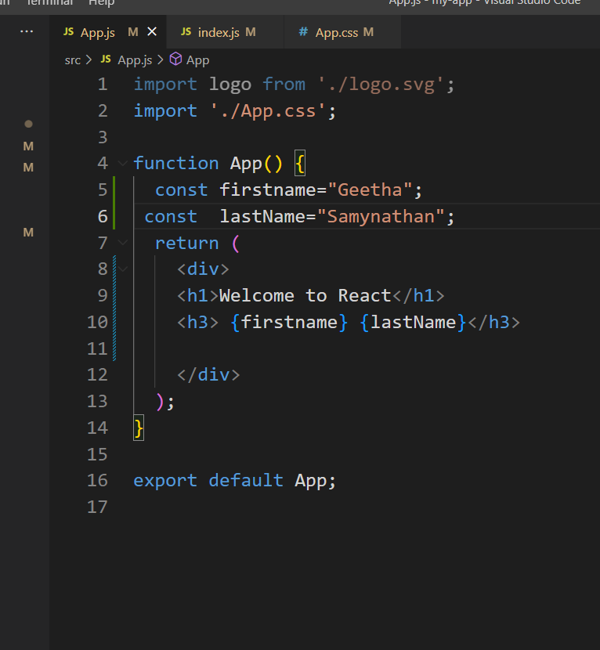

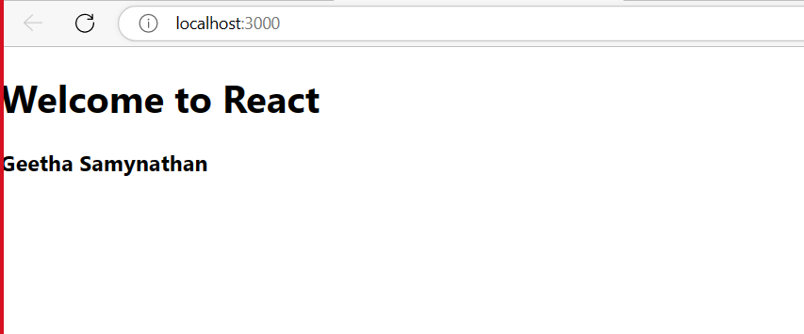

Example for Rendering Elements based on Condition

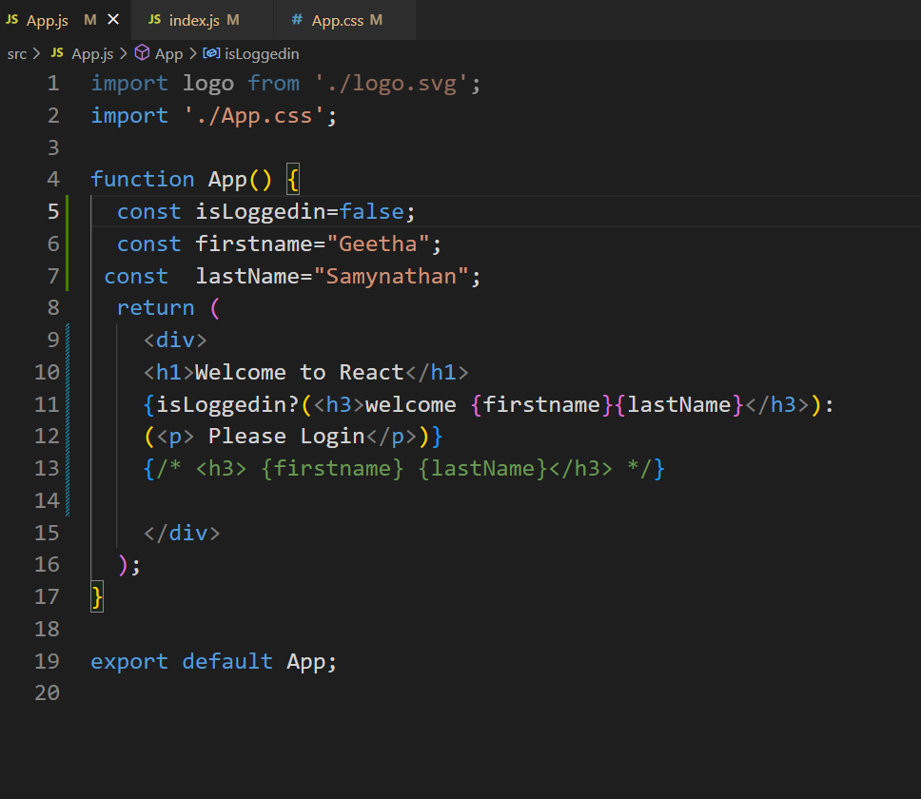

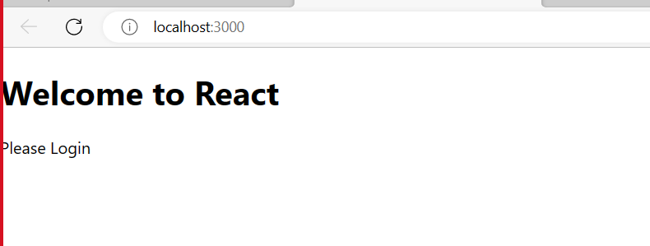

Change the value isLoggedIn=true and observe the output

Example to understand the virtual DOM:

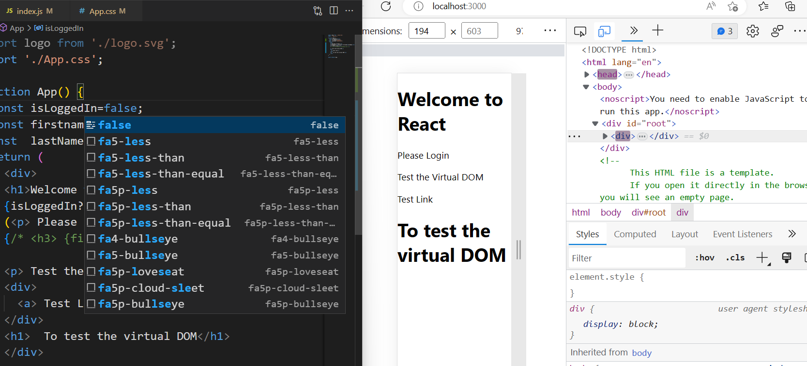

Add new File Greetings.js in src folder

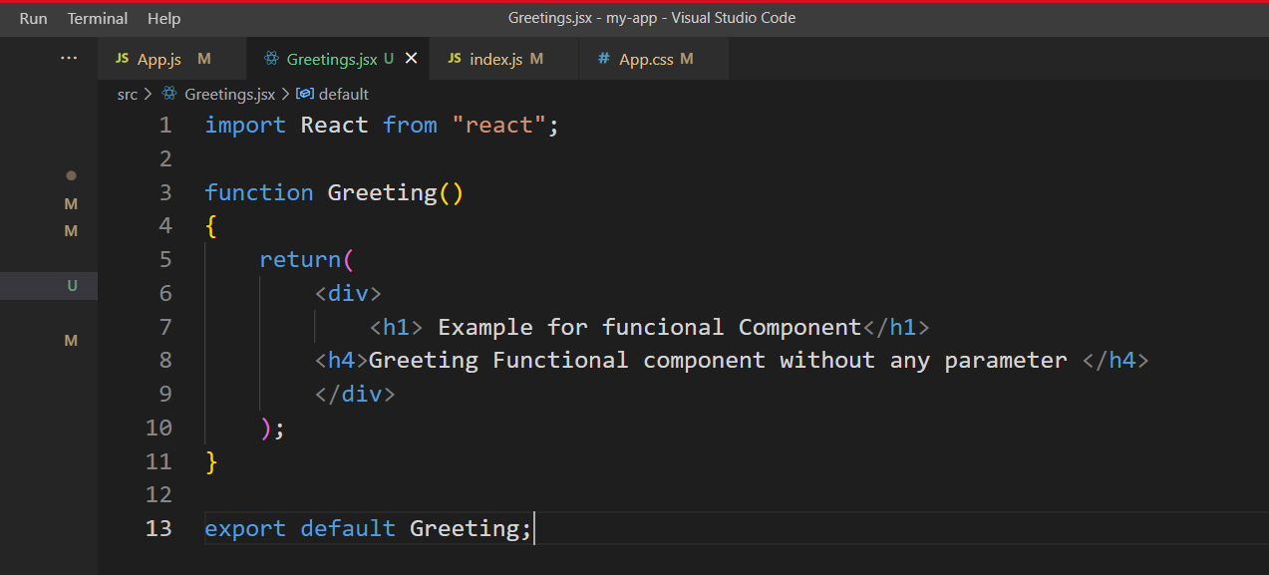

App.Js

import logo from './logo.svg';

import './App.css';

import Greeting from './Greetings';

function App() {

  const isLoggedIn=false;

  const firstname="Geetha";

 const  lastName="Samynathan";

  return (

    <div>

    <h1>Welcome to React</h1>

    {isLoggedIn?(<h3>welcome {firstname}{lastName}</h3>):

    (<p> Please Login</p>)}

    <Greeting/>

    </div>

  );

}

export default App;

output

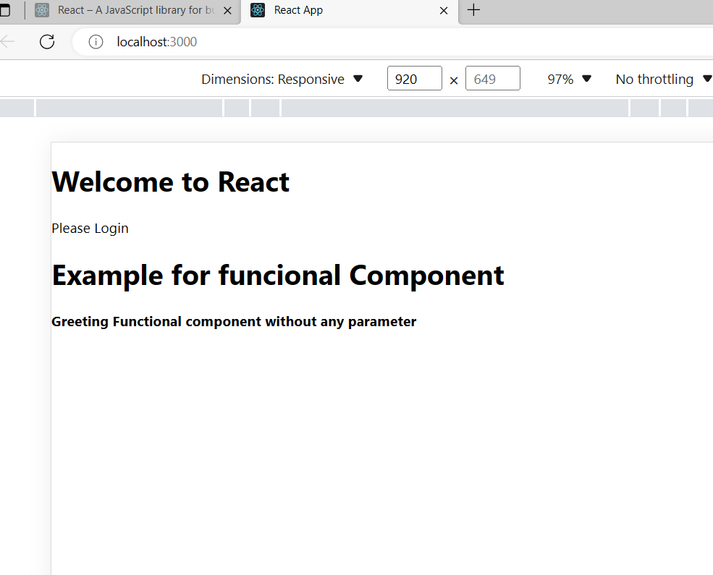

Example for functional component with Props (input parameter)

Greetings.js

import React from "react";

function Greeting(props)

{

    return(

        <div>

            <h1> Example for funcional Component</h1>

        <h4>Greeting Functional component without any parameter </h4>

        <p> input paramter : Name ={props.name} Gender={props.gender}</p>

        </div>

    );

}

export default Greeting;

App.js

import logo from './logo.svg';

import './App.css';

import Greeting from './Greetings';

function App() {

  const isLoggedIn=false;

  const firstname="Geetha";

 const  lastName="Samynathan";

  return (

    <div>

    <h1>Welcome to React</h1>

    {isLoggedIn?(<h3>welcome {firstname}{lastName}</h3>):

    (<p> Please Login</p>)}

    <Greeting name="Geetha" gender="female"/>

    </div>

  );

}

export default App;

output

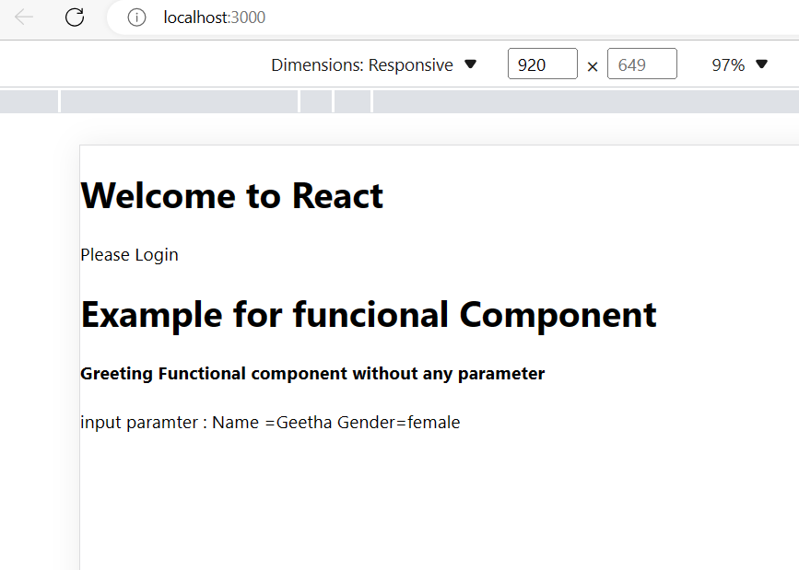

Example for Event Binding in React.js

import React from "react";

function ShowAlert()

{

    alert(' Alert Box');

}

 const sample=() =>{ console.log('Arraow function called'); }

 const clickHandler=()=>{sample(); ShowAlert();}

function Greeting(props)

{

    return(

        <div>

            <h1> Example for functional Component</h1>

        <h4>Greeting Functional component without any parameter </h4>

        <p> input paramter : Name ={props.name} Gender={props.gender}</p>

        <button onClick={clickHandler.bind(this)}>Click Here</button>

        </div>

    );

}

export default Greeting;

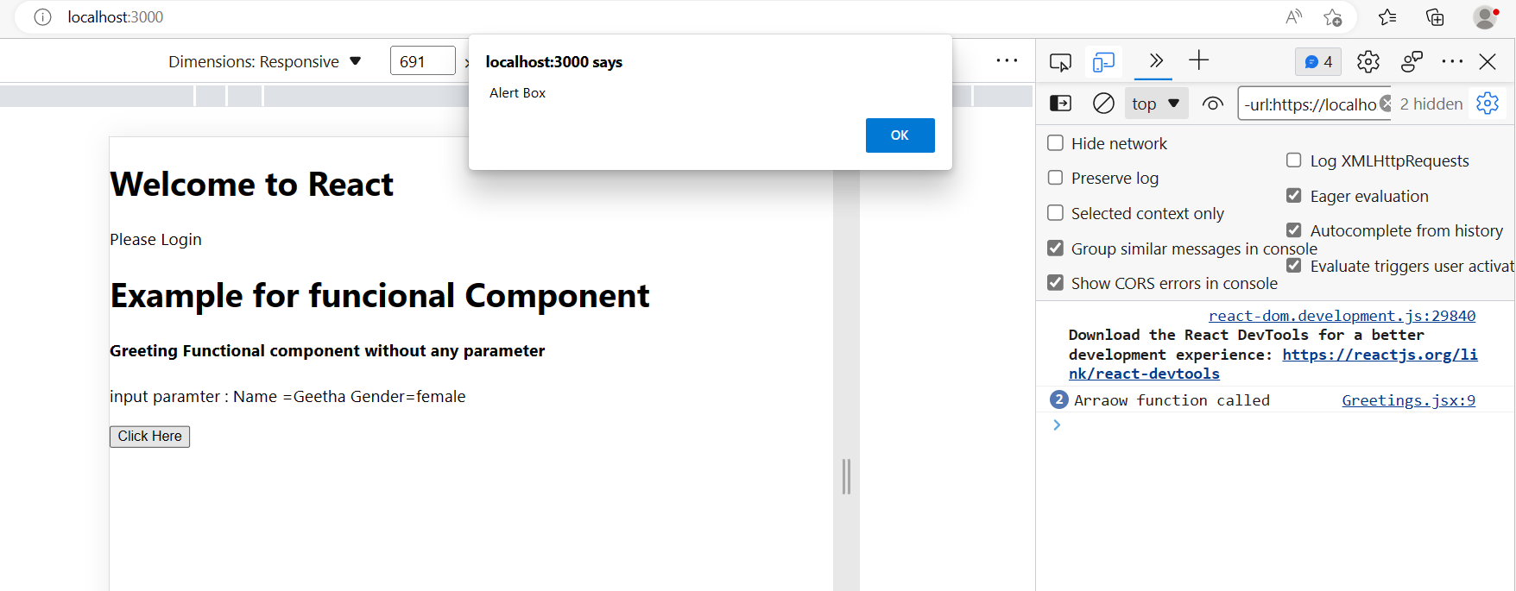

SimpleList.jsx

import React from "react";

const Names=[

    {name:'Divya'},

    {name:'Akash'},

    {name:'Rahul'},

    {name:'yeswanth'},

    {name:'Anupam'}

];

export default function SimpleList()

{

    const Names=[

        {id:101,name:'Divya'},

        {id:102,name:'Akash'},

        {id:103,name:'Rahul'},

        {id:104,name:'yeswanth'},

        {id:105,name:'Anupam'}

    ];

    return(

        <div>

            <ul>

            {Names.map(data =>(

                <li key={data.id}>{data.id}  {data.name}</li>

            ))}

            </ul>

        </div>

    );

}

App.js

import logo from './logo.svg';

import './App.css';

import Greeting from './Greetings';

import SimpleList from './simpleList';

function App() {

  const isLoggedIn=false;

  const firstname="Geetha";

 const  lastName="Samynathan";

  return (

    <div>

    <h1>Welcome to React</h1>

    {isLoggedIn?(<h3>welcome {firstname}{lastName}</h3>):

    (<p> Please Login</p>)}

    <Greeting name="Geetha" gender="female"/>

    <SimpleList></SimpleList>

    </div>

  );

}

export default App;

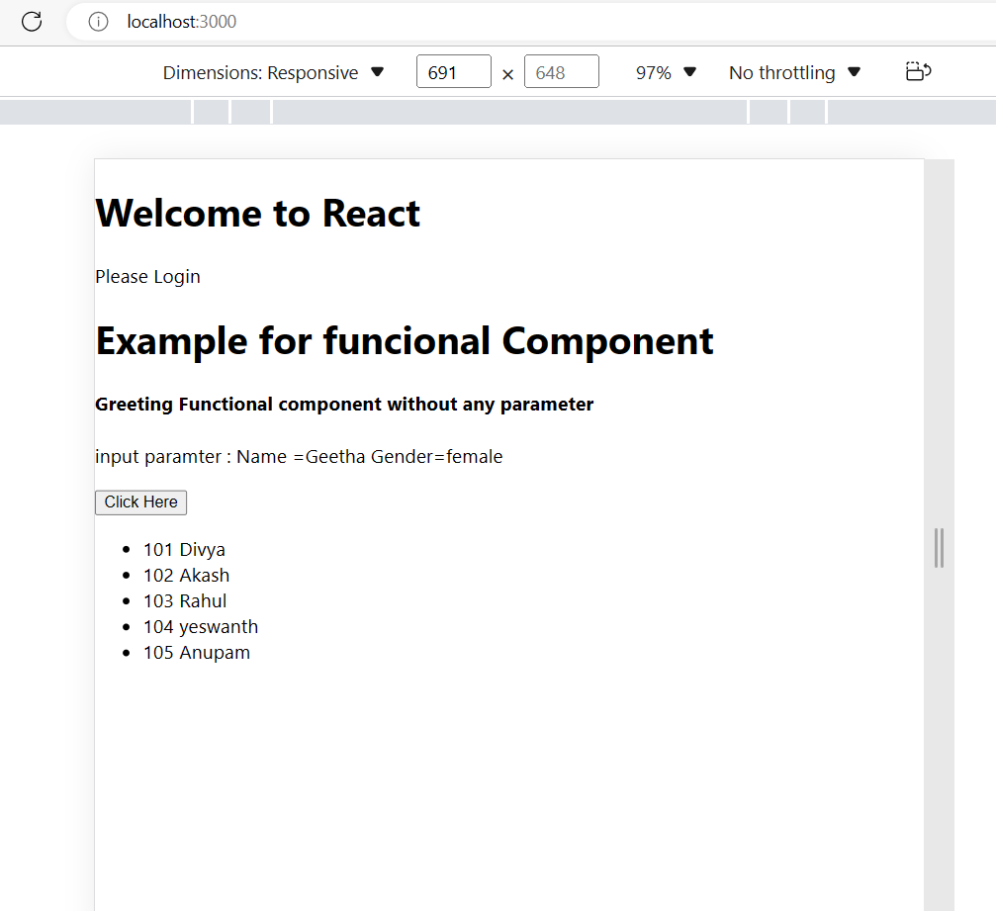

ObjectList Example

import React from "react";

const Users=[

    {

        id:1,

        name:"peter",

        email:"peter@yahoo.co.in",

        Phone:'987-654-3210'

    },

    {

    id:1,

    name:"Raja",

    email:"Raja@yahoo.co.in",

    Phone:'987-654-3210'

    },

    {

    id:1,

    name:"Fransy",

    email:"Fransy@yahoo.co.in",

    phone:'987-654-3210'

    }

];

export default function ObjectList()

{

   return(

    <>

    <ul>

        {Users.map((data =>(

            <li key={data.id}>

                <p>{data.name}</p>

                <p>{data.email}</p>

                <p>{data.phone}</p>

            </li>

        )))}

    </ul>

    </>

   );

}

App.js

import logo from './logo.svg';

import './App.css';

import Greeting from './Greetings';

import SimpleList from './simpleList';

import ObjectList from './ListWithObject';

import NestedList from './NestedList';

function App() {

  const isLoggedIn=false;

  const firstname="Geetha";

 const  lastName="Samynathan";

  return (

    <div>

    <h1>Welcome to React</h1>

    {isLoggedIn?(<h3>welcome {firstname}{lastName}</h3>):

    (<p> Please Login</p>)}

    <Greeting name="Geetha" gender="female"/>

    <SimpleList></SimpleList>

    <ObjectList />

    <NestedList />

    </div>

  );

}

export default App;

Create new file with the name of NestedList.jsx

import React from "react";

const Users1=[

    {

        id:1,

        name:"peter",

        email:"peter@yahoo.co.in",

        Phone:'987-654-3210'

    },

    {

    id:2,

    name:"Raja",

    email:"Raja@yahoo.co.in",

    Phone:'987-654-3210'

    }

];

const Users2=[

    {

        id:1,

        name:"Fransy",

        email:"Fransy@yahoo.co.in",

        Phone:'987-654-3210'

    },

    {

    id:2,

    name:"Yeshwanth",

    email:"Yeshwanth@yahoo.co.in",

    Phone:'987-654-3210'

    }

];

 const joinList=[Users1,Users2];

export default function NestedList()

{

    return(

       <div>

        {

        joinList.map((nestedItem,i)=>(

            <ul Key={i++}>

                <h3>List{i}</h3>

                {nestedItem.map(data =>(

                    <li key={data.id}>

                        <div>{data.id}</div>

                        <div>{data.name}</div>

                        <div>{data.email}</div>

                        <div>{data.phone}</div>

                    </li>

                ))}

            </ul>

        ))}

    </div>

    );

}

App.js

import logo from './logo.svg';

import './App.css';

import Greeting from './Greetings';

import SimpleList from './simpleList';

import ObjectList from './ListWithObject';

import NestedList from './NestedList';

function App() {

  const isLoggedIn=false;

  const firstname="Geetha";

 const  lastName="Samynathan";

  return (

    <div>

    <h1>Welcome to React</h1>

    {isLoggedIn?(<h3>welcome {firstname}{lastName}</h3>):

    (<p> Please Login</p>)}

    <Greeting name="Geetha" gender="female"/>

    <SimpleList></SimpleList>

    <ObjectList />

    <NestedList />

    </div>

  );

}

export default App;

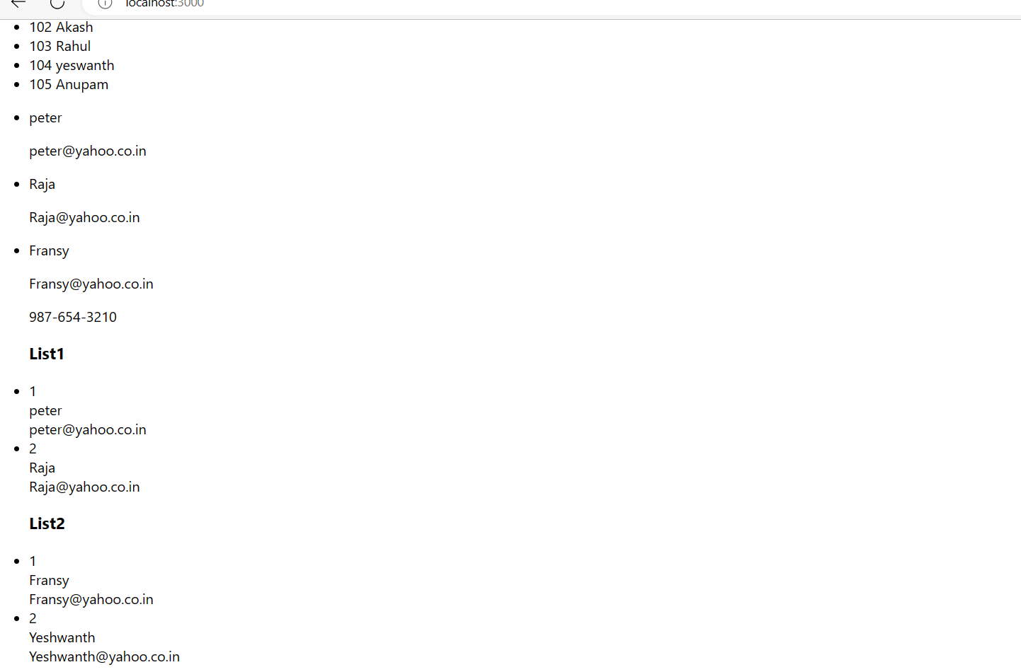

Class Component in React.js

To define a React component class, We have to create a class and extend React.Component class. Lets say we want to create an Employee Component and this Component should return the Element which displays Employee Details.

Create Employee class and extend it from React.Component. Output of any Class Component we create is dependent on the return value of a Method Called render(). The render() method is the only required method needs to be implemented in a class component.

lets create a div element which displays employee details like ID, Name , Location, Salary and return the div from this Method. To access the attributes that will be passed to this Component Class, in React we use this.props. Attribute Name. this.props contains the props that were defined by the caller of this component.

class Employee extends React.Component {

render(){

return <div>

<h2>Employee Details...</h2>

<p>

<label>Name : <b>{this.props.Name}</b></label>

</p>

</div>;

}

}

import React from "react";

class Employee extends React.Component

{    render()

    {

        return(

            <div>

                <h1> Class component Demo</h1>

                <div>

                    <p>FullName: {this.props.name}</p>

                    <p>Designation: {this.props.designation}</p>

                    <p>City: {this.props.city}</p>

                </div>

            </div>

        )

        }

}

 export default Employee;

app.js

import logo from './logo.svg';

import './App.css';

import Greeting from './Greetings';

import SimpleList from './simpleList';

import ObjectList from './ListWithObject';

import NestedList from './NestedList';

import Employee from './ClassComponentsDemos/ClassComponentDemo';

import Counter from './ClassComponentsDemos/ClassComponentDemo2';

function App() {

  const isLoggedIn=false;

  const firstname="Geetha";

 const  lastName="Samynathan";

  return (

    <div>

      {/* <Employee name="Geetha Samynathan" designation="Senior Consultant" city="Tirupur"/> */}

    </div>

  );

}

export default App;

app.js

import logo from './logo.svg';

create ClassComponentDemo.jsx

import React from "react";

class Employee extends React.Component

{

    render()

    {

        return(

            <div>

                <h1> Class component Demo</h1>

                <div>

                    <p>FullName: {this.props.name}</p>

                    <p>Designation: {this.props.designation}</p>

                    <p>City: {this.props.city}</p>

                </div>

            </div>

        );

    }

}

 export default Employee;

app.js

import logo from './logo.svg';

import './App.css';

import Employee from './ClassComponentDemo';

function App() {

  return (

    <div>

      <Employee name="Geetha Samynathan" designation="Senior Consultant" city="Tirupur"/>

    </div>

  );

}

export default App;

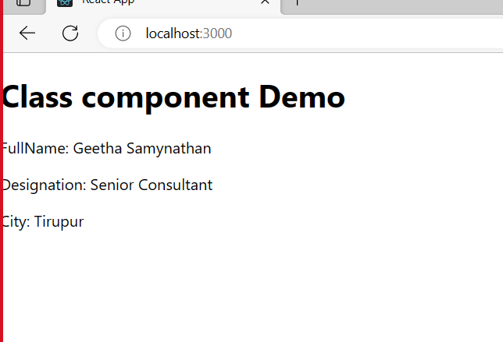

Create folder with the name ComponentClassDemonstration

Add move Previous example in that folder

Add new File with the name of ClassComponentDemo2.jsx

Example to declass the classcomponent without state

import React from "react";

 export default class Counter extends React.Component

 {     constructor(props)

     {

        super(props)

        count=0;

     }

    incrementCount =() =>{

      this.count=this.count+1;

      }

    render(){

        return(

            <div>

            <p> Count : {this.count}</p>

            <button onClick={this.incrementCount}>Increment</button>

            </div>

        )

    }

 }

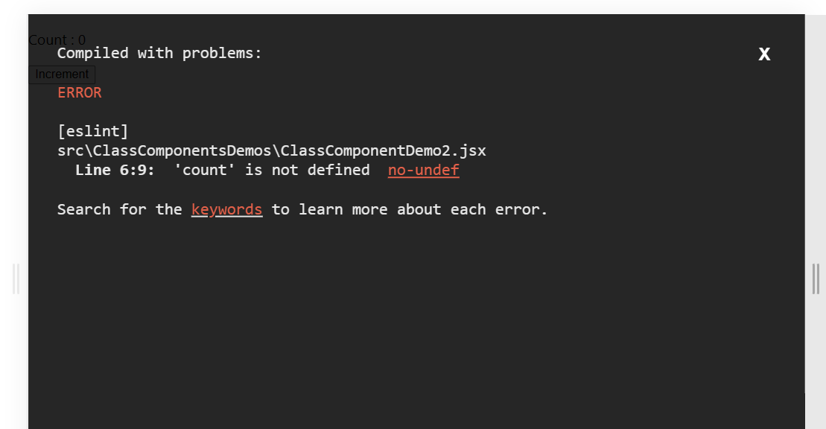

So modify the code shown as below to maintain the state.

import React from "react";

 export default class Counter extends React.Component

 {     constructor(props)

     {

        super(props)

        this.state={count:0}; // variable decalration and initialization

     }

    incrementCount =() =>{

        //Change the value of the variable in State  needs to use SetState Method

        this.setState(prevState =>({

            count:prevState.count+1

        }))

      }

    render(){

        return(

            <div>

        {/* to access the state variable we need to use this.state.variablename */}

            <p> Count : {this.state.count}</p>

            <button onClick={this.incrementCount}>Increment</button>

            </div>

        )

    }

 }

Output

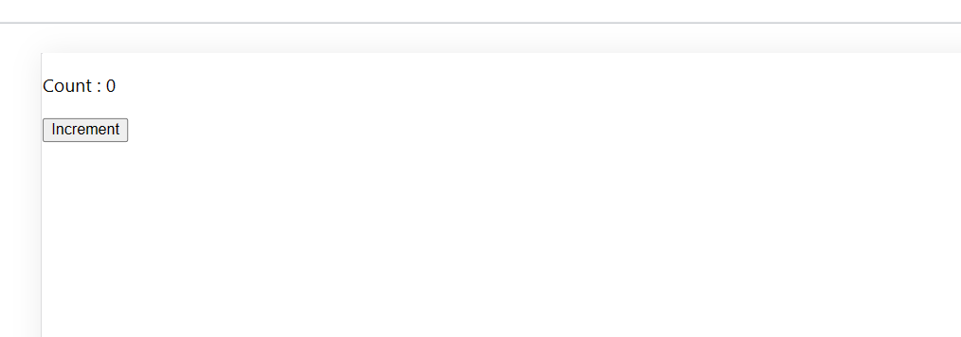

After click the button 2 times

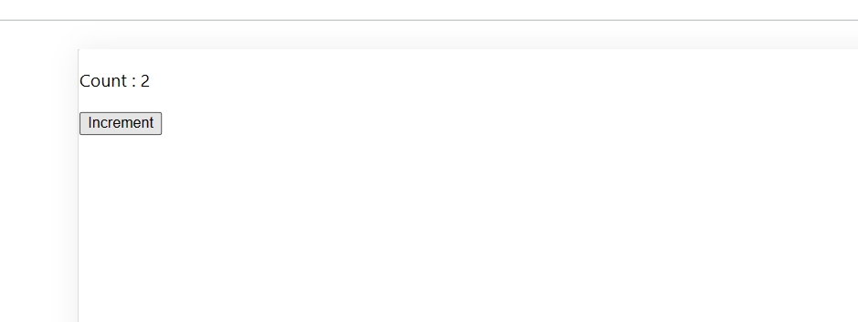

Now try without calling super() in Constructor

import React from "react";

 export default class Counter extends React.Component

 {     constructor(props)

     {

       // super(props)

        this.state={count:0}; // variable decalration and initialization

     }

    incrementCount =() =>{

        //Change the value of the variable in State  needs to use SetState Method

        this.setState(prevState =>({

            count:prevState.count+1

        }))

      }

    render(){

        return(

            <div>

        {/* to access the state variable we need to use this.state.variablename */}

            <p> Count : {this.state.count}</p>

            <button onClick={this.incrementCount}>Increment</button>

            </div>

        )

    }

 }

You will be getting the below error

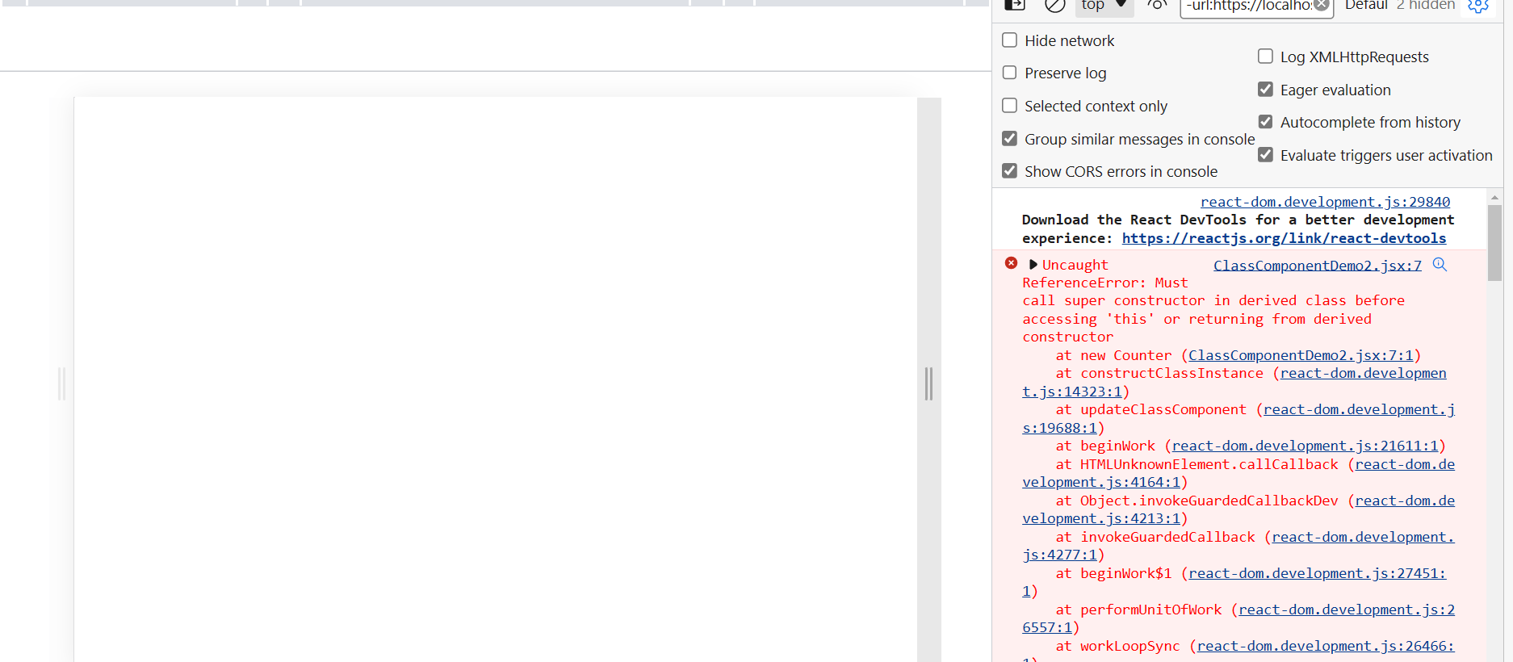

So super Constructor is must